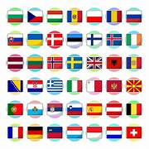
International Service Chairman (ISC)
The ISC usually serves for 3 years

Join the District Executive Committee (DEC)
and have fun fostering international understanding!

Are you willing to support Clubs in their efforts and give a shout out for their efforts?

A big part of the role is communicating with others:
- with Association as needed;
and
- with Club ISOs from the 10 Clubs in DEC 129, keeping in touch, responding to queries and giving advice and support whenever necessary.

Once a year in December, you will also need to gather all the Club international information together for the District International Service Report.
Be prepared to be amazed at how much Clubs do!

DEC members come along, whenever they can, to 4 short Committee Meetings at Lanhydrock Hotel and 3 District Meetings a year as well as the District Assembly.
Travel expenses are paid for the 4 Committee Meetings.

The International Service Chairman role will start on 1st July 2026.
On the DEC, we aim to support each other in a friendly fashion and go with the majority on decisions. If you are a team player, please consider joining us!

If you want to know more, get in touch with us on innerwheel129@gmail.com Include your phone number if you would prefer to have a chat!
Looking forward to hearing from you!

